Lecture 4
Distributed Objects
For Chapter 7, 8
For Chapter 7

You need to read your book and practice the exercises. This is just an extra note for the chapter.
Read this lecture after you have read chapters 7&8 of your second textbook.

Introduction

So far, we learned how to send and receive messages (strings) in a unicast and multicast systems. We now go over sending and receiving via objects.
Note: Since we are dealing with threads in java I name a process: a program.

7.1 Message Passing versus Distributed Objects

The message passing systems may not be appropriate for complex applications because:
- Processes (programs) in the message passing paradigm are tightly coupled. If the communication between client/server disrupted, then the session cannot continue.
- The message passing paradigm is data-oriented. The processes transfer data to each other.

In the distributed object paradigm it is the objects that communicate with each other. Since an object contains data values in the instance variables and methods not only a process (program) sends and receives data values a process (program) can also call a method of an object which resides in a program of another website on the internet (figure 7.1).

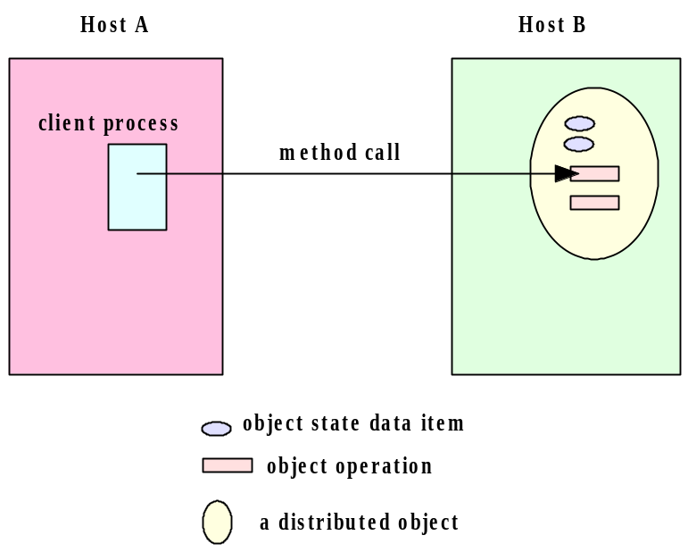
7.2 An Archetypal Distributed Object Architecture

Figure 7.2 in page 206 shows an archetypal distributed object. On the server side the server program creates an object which is called: object server. The object is registered by the (object) registry (A registry is an object on the server side). On the client side the client program creates an object client. The client program then looks at the (object) registry to make sure the object can be referenced. The client object uses this reference to call the methods of the object server. These methods are called remote methods. A call to a remote method is processed by a client proxy which is a software that knows how to communicate with the server proxy. The sever proxy refers to the object server to invoke the method and send the result back to the client proxy. The client proxy in turn gives the result to the object client.

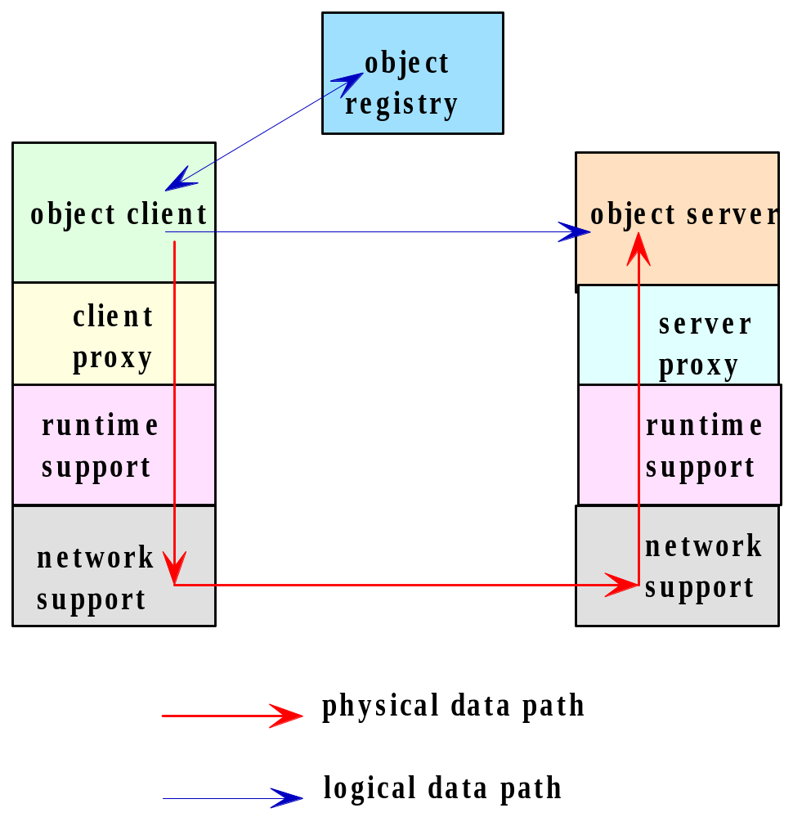

7.3 Distributed Object System

The java programmer use Java Remote Method Invocation (RMI), Common Object Request Broker Architecture (CORBA) and/or the Distributed Component Object Model (DCOM) software for distributed programming. In this and the next chapters, we learn how to use Java RMI and its communication mechanism.

7.4 Remote Procedure Calls

The base of RMI is the Remote Procedure Call (RPC). RPC is used in the procedural programming language like C. Figure 7.3 shows how processes over the network call a procedure (function). Process A calls a procedure proc1 that is resided in process B. Process B executes the procedure and sends the return value (if any) to process A. Figure 7.4 is more clear and precise. In this figure (see the book) a process in our computer calls procedure: proc1. This procedure calls procedure: proc2 which is defined on a remote computer. The system executes: proc2 and returns the result to the caller (proc1).

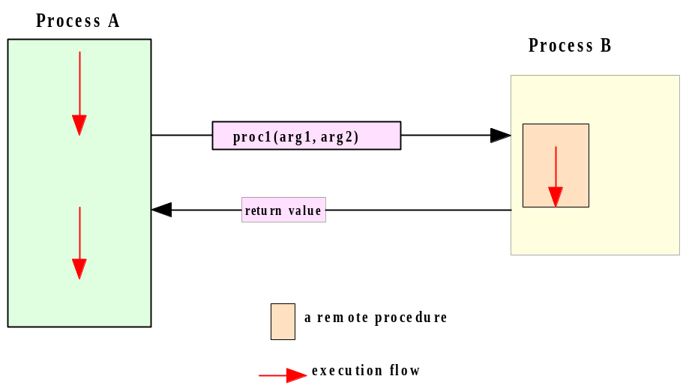

7.5 Remote Method Invocation

RMI is an extension of RPC. In RPC we are dealing with procedures. In RMI we deal with objects. We define a class on the client side to create a client object and a class on the server side to create a server object. We also define an interface. A server class implement the interface. The interface that we define inherits the java interface: Remote. The interface that we define has the signature of some methods that the client can call. The server side implements this interface to define the methods of the interface. The client side does not implement this interface but the interface is available to be used.

7.6 The Java RMI Architecture

Figure 7.5 shows the mechanism of a remote call. The client side is on the left and the server side is on the right.
The object client sends a remote method call to its stub (i.e. proxy). The client remote reference layer sends the call to the client transport layer. The transport layer sends the call to the transport layer of the server. This layer sends the call to the server reference layer to interpret for the object server. The server executes the call and sends the result back to the object client.

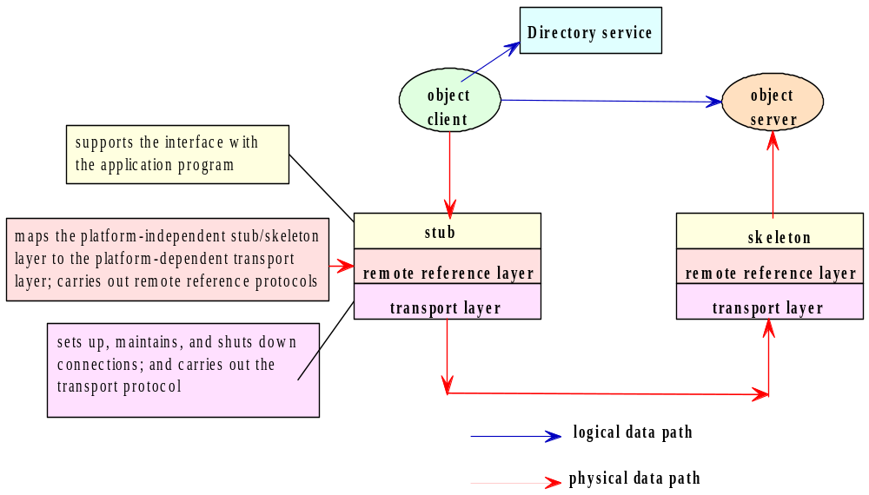

The stub is an object, as a gateway for the client program. When the client program calls a method that is implemented on the server program the stub does the following:

1. Connects to the remote Virtual Machine (JVM),
2. It sends (marshals) the arguments of the method to the remote Virtual Machine (JVM),
3. Waits for the result
4. Reads (unmarshals) the return value
5. Returns the value to the caller.

The skeleton is an object, as a gateway for the server side object. All the incoming requests are routed through it. When the skeleton receives the incoming request, it does the following tasks:

1. Reads the arguments for the remote method
2. Calls the method on the actual remote object
3. Sends (marshals) the result to the caller.

7.7 & 7.8 the API for Java RMI

I explain the API through a simplified version of the client server programs from pages 220-224. We need java interface and classes to:

1. Create the remote interface.
2. Use (but not implement) the interface on the client side.
3. Implement the remote interface by a class on the server side.
4. Start the registry service by rmiregistry tool

Note: On the client side we need to define at least one class. On the server side we need to define at least two classes.

Example 1: In the following client-server programs the client calls a method of the server.

The client side class and interface:

import java.rmi.*;
public interface HelloInterface extends Remote {
public String sayHello(String name) throws RemoteException;
}

import java.rmi.*;

public class HelloClient{
public static void main(String args[]){
try{
int port = 16790;
String host = "localhost";
String registryURL = "rmi://" + host + ":" + port + "/hello";
HelloInterface h = (HelloInterface)Naming.lookup(registryURL);
System.out.println("Lookup completed " );
String message = h.sayHello("Donald Duck");
System.out.println("HelloClient: " + message);
}
catch (Exception e){
e.printStackTrace();
}
}
}

The server side classes and interface:

import java.rmi.*;
import java.rmi.registry.LocateRegistry;

public class HelloServer{
public static void main(String args[]){
try{
int port = 16790;
String host = "localhost";
HelloImpl exportedObj = new HelloImpl();
LocateRegistry.createRegistry(port);
String registryURL = "rmi://" + host + ":" + port + "/hello";
Naming.rebind(registryURL, exportedObj);
System.out.println("Hello Server ready.");
}catch (Exception e){
e.printStackTrace();
}
}
}

import java.rmi.*;
import java.rmi.server.*;

public class HelloImpl extends UnicastRemoteObject implements HelloInterface {

public HelloImpl() throws RemoteException {
super( );
}

public String sayHello(String name) throws RemoteException {
return "Hello, World!" + name;
}
}

Description:

The interface:

public interface HelloInterface extends Remote{
public String sayHello(String name) throws RemoteException;
}

This is a java interface. The java class: Remote informs the client that the method: sayHello is implemented remotely (on the server side). This interface is not implemented on the client side.

Note: Since we write all the programs with eclipse you do not have to memorize which exception class should be used here and there. The eclipse tells you which exceptions you need.

Note that this interface is on both the client and server sides. This interface is implemented by the class: HelloImpl on the server side and is not implemented in the client program.

The RMI system has a registry objects. Every remote object must have a name registered in the registry.

The server side:

The class HelloImpl:
- The server creates an object of this class. This object is going to be the remote object. The method: sayHello of this remote object can be called by the client program.

The class HelloServer:
- Method: main:
  - String registryURL = "rmi://" + host + ":" + port + "/hello": This make the string: "rmi://localhost:16790/hello". This string is going to be registered in the registry as the name of the remote object that the variable: exportedObj refers to.
Note: The word: hello is optional. You can change it on both sides to any name.
  - LocateRegistry.createRegistry(port): Creates and exports a registry object on the specified port.
  - Naming.rebind(registryURL, exportedObj): Naming is a class in the package rmi. The method: rebind associates (binds) the above string (blue underlined) with the remote object: exportedObj, which is an object of type class: HelloImpl.

The client side:

The class HelloClient:
- String registryURL = "rmi://" + host + ":" + port + "/hello": This make the string: "rmi://localhost:16790/hello". This string must be in the rmi registry as the name of a remote object. The variable: host is the host where the registry is located. The variable: port is the port number on which the registry on the server side accepts calls. Both host and port are optional. If host is omitted, the host defaults to the local host. If port is omitted, then the port defaults to 1099, the "well-known" port that rmi registry uses.
- HelloInterface h = (HelloInterface)Naming.lookup(registryURL): The method: looks up for the argument (the blue underlined). This name refers to a remote object. Therefore, the variable: h refers to the remote object. Now h can access to any public method and variable of this remote object which is of type class: HelloImpl.
- h.sayHello("Donald Duck"): passes the argument: to the following method. The method returns the string: "Hello, World!Donald Duck".
public String sayHello(String name) throws RemoteException{
return "Hello, World!" + name;
}

Exercise 1: Write a client server program using RMI. The client sends two integers. The server subtract these numbers and sends the result back to the client.

Exercise 2: Write a client server program using RMI for a bank account. The client sends two integers. The server subtract these numbers and sends the result back to the client. Use the following interface.
import java.rmi.Remote;
import java.rmi.RemoteException;

public interface AccountInterface extends Remote {
//In creating an account, it is the bank that selects an account number. In
//our project the first new account is 100, the next is 101, next is 102,...
//Anyone can open a new account. It does not matter if the person has already accounts public String createAccount(String name, float balance) throws RemoteException;

//If the name with accountNo is in the bank return the person balance as a string.
//otherwise either name has no account or his account no is wrong.
public String getBalance(String name, int accountNo) throws RemoteException;

// The account number with the name must be in the bank.
// There is not enough fund return to the user a message.
// There is enough funds. Withdraw and return the new balance.
public String withdraw(String name, float amt, int accountNo)throws RemoteException;

// The account number with the name must be in the bank.
// If account number with the name is in the bank, deposit and return the new balance.
public String deposit(String name, float amt, int accountNo) throws RemoteException;

// Both account numbers with the same name must be in the bank.
// There is not enough fund in the account that is goind to transfer return to the user a message.
// There is enough funds. Withdraw and return the new balance.
public String transfer(String name, int fromAccount, int toAccount, float amt) throws RemoteException;
}
Exercise 3: Write a client server program using RMI. The clients sends an array of integer to the server. The server sorts the array and returns it back to the client.
7.9 Steps for Building an RMI Application

If you have java version 1.4 or higher you do not need this section. In this case you do not need the stub or the skeleton and you can use eclipse like you did in the previous chapters

We may download RMI Plug-in for Eclipse from http://www.genady.net/rmi/v20/index.html. But this is not necessary. I explain this section without using this plug-in. The following steps for Win 7:

1. Go to the DOS window and enter: rmic. If you do not getting error telling something like:

'rmic' is not recognized as an internal or external command, operable program or batch file.

Then skip the steps 2-10.

2. Go to Program Files. There should be a folder named: Java. This folder should have two folders: jdk1.7... and jre7... (I have: jdk1.7.0_03 and jre7). Therefore I write on these versions. But if you have different version simply follow the steps for your version.

3. Go to the folder: C:\Program Files\Java\jdk1.7.0_03\bin. There should be file named: rmic.exe. This is the rmi compiler. It makes the stub class. Note that we do not have a skeleton class in the server side and a stub class in the client side. The rmic compiler makes the file stub class and we copy this file into the client side.
4. Go to: Control Panel\All Control Panel Items\System to see:
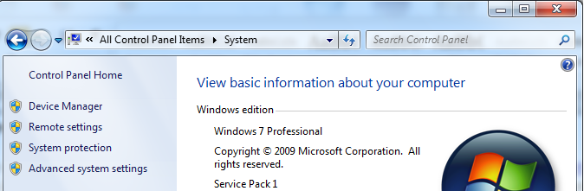
5. Click on the tab: Advanced to see:

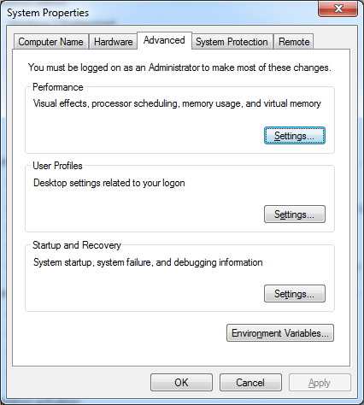

6. Click on: Environment Variables and find path in the lower window (System variable) to see:
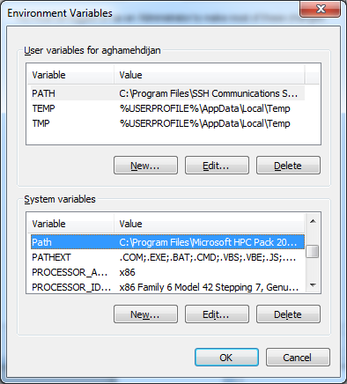

7. Click on edit to see something like:
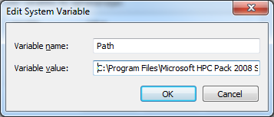
8. In the window labeled: Variable Value go to the end and copy/paste:
;C:\Program Files\Java\jdk1.7.0_03\bin

Note: If your jdk version is different use yours.
Note: Do not forget the semicolon (i.e. ;) which comes at the beginning.
9. Click OK, OK, and OK. Reboot (restart) your computer.
10. In the DOS window enter: rmic. You should see something like:
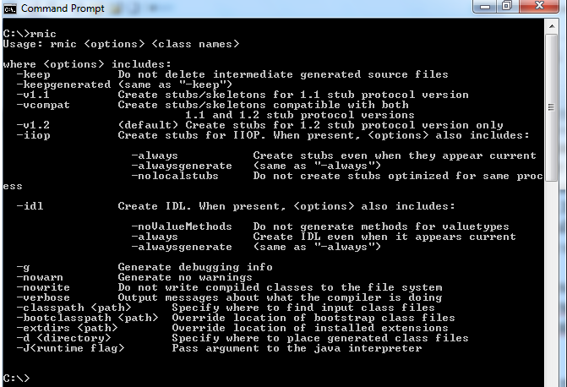

Note: It does not matter from which directory you enter: rmic. It should work from any directory.

11. Like in the lecture for sockets make a folder. In this folder make two folders name: Server and Client. Click on the eclipse icon and make the folder: Server a workstation and make a project. But this time we want all the *.java and *.class files to be in the same folder. Therefore we make a project and activate the radio button labeled: Use project folder as root for sources and class files:

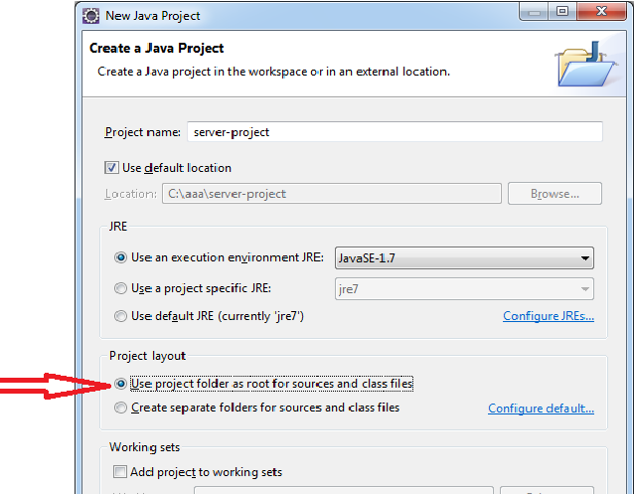

12. Click on the eclipse icon again and make the folder: Client a second workstation and make a project.

Note: Here also activate the radio button: Use project folder as root for sources and class files.

13. We want to run the client-server of example 1. In the eclipse editor for the server make a java interface name: HelloInterface. Make a class named: HelloImpl and a class named: HelloServer. Copy/paste the interface and these two classes from example 1.

14. In the eclipse editor for the client make a java interface name: HelloInterface. Make a class named: HelloClient. Copy/paste the interface and these two classes from example 1.

15. In the DOS window go to the server project folder (the place that you have all the *.java and *.class) and enter: rmic HelloImpl

Note: This is HelloImpl.class. Eclipse makes: *.class for all *.java files. If you do not see the files *.class enter javac *.java in the DOS window to make these files.

16. Now you should see a new file named: HelloImpl_Stub.class. Copy/paste this file to the client project folder (the place that you have all the *.java and *.class).

Note: It is easier to do this copy/paste from Windows than the Dos window.

Note: Every time you make changes in the file: HelloImpl.class you must do this step.

17. Run server program from eclipse. You should see the following in the console window:

RMI registry created at port 16790
Hello Server ready.
18. Now run the client program to see the following output in its console:

Lookup completed
HelloClient: Hello, World!Donald Duck
For Chapter 8
In this chapter, more application of the API of rmi is presented. The chapter explains how to use the java security manager. We go over two rmi programs: A more sophisticated program and a program that deals with the security manager.

8.1 Client Callback

A client program in real time does not know when the remote object is available. For example, it takes some time to obtain the result (like sorting millions of names) that should be sent back to the client. In this case the client program has to poll (check) for the availability of the result repeatedly until it is available. This idea can be coded as follows:

CallbackServerInterface h = (CallbackServerInterface)Naming.lookup(registryURL);
while(!(h.hasBiddingStarted())
;

Where the method: hasBiddingStarted() is a remote method that returns true when the remote object obtains the result to be sent to the client. As long as this remote method returns false the above while-loop cycles around. Obviously this is not an efficient solution. The thread that is responsible for the execution of the client program is wasting CPU time by sitting on this loop. A more efficient solution is the callback technique. In this technique we code the client to go to sleep for a period of time. In this case CPU leaves the thread that is executing the client program to do (execute) some useful work for other programs in the system. Let us clarify this technique through an example.

Example 2: The following client-server program implements the callback technique.

The server side:
import java.rmi.*;

public interface CallbackClientInterface extends Remote{
public String notifyMe(String message) throws RemoteException;
}
import java.rmi.*;

public interface CallbackServerInterface extends Remote
{
public String sayHello( ) throws RemoteException;

public void registerForCallback(CallbackClientInterface callbackClientObject)
throws RemoteException;

public void unregisterForCallback(CallbackClientInterface callbackClientObject)
throws RemoteException;
}

import java.rmi.*;
import java.rmi.registry.LocateRegistry;

public class CallbackServer{
public static void main(String args[]){
try{
int port = 1234;
String host = "localhost";
LocateRegistry.createRegistry (port);
CallbackServerImpl exportedObj = new CallbackServerImpl();
String registryURL = "rmi://" + host + ":" + port + "/callback";
Naming.rebind(registryURL, exportedObj);
System.out.println("Callback Server ready.");
}
catch (Exception re){
System.out.println("Exception in HelloServer.main: " + re);
}
}
}

import java.rmi.*;
import java.rmi.server.*;
import java.util.Vector;

public class CallbackServerImpl extends UnicastRemoteObject implements CallbackServerInterface
{
private static final long serialVersionUID = 1L;
private Vector<CallbackClientInterface> clientList;

public CallbackServerImpl() throws RemoteException
{
super( );
clientList = new Vector<CallbackClientInterface>();
}

public String sayHello( )throws RemoteException
{
return("hello");
}

public synchronized void registerForCallback
(CallbackClientInterface callbackClientObject)throws RemoteException
{
if (!(clientList.contains(callbackClientObject)))
{
clientList.addElement(callbackClientObject);
System.out.println("Registered new client ");
doCallbacks();
}
}

public synchronized void unregisterForCallback(
CallbackClientInterface callbackClientObject) throws RemoteException{

if (clientList.removeElement(callbackClientObject)){
System.out.println("Unregistered client ");
}else{
System.out.println("unregister: clientwasn't registered.");
}
}

private synchronized void doCallbacks( ) throws RemoteException{
System.out.println("**************************************\n Callbacks initiated ---");
for (int i = 0; i < clientList.size(); i++){
System.out.println("doing "+ i +"-th callback\n");
CallbackClientInterface nextClient =
(CallbackClientInterface)clientList.elementAt(i);
nextClient.notifyMe("Number of registered clients=" + clientList.size());
}
System.out.println("********************************\n Server completed callbacks ---");
}
}

The client side:

import java.rmi.*;
//Is implemented in this client side.
public interface CallbackClientInterface extends Remote{
public String notifyMe(String message) throws RemoteException;
}
import java.rmi.*;
//Is implemented on the server side side.
public interface CallbackServerInterface extends Remote {
public String sayHello( ) throws RemoteException;

public void registerForCallback(CallbackClientInterface callbackClientObject)
throws RemoteException;

public void unregisterForCallback(CallbackClientInterface callbackClientObject)
throws RemoteException;
}

import java.rmi.*;
import java.rmi.server.*;

public class CallbackClientImpl extends UnicastRemoteObject
implements CallbackClientInterface {
private static final long serialVersionUID = 1L;

public CallbackClientImpl() throws RemoteException
{
super( );
}

public String notifyMe(String message)
{
String returnMessage = "Call back received: " + message;
System.out.println(returnMessage);
return returnMessage;
}
}

import java.util.Scanner;
import java.rmi.*;

public class CallbackClient {
public static void main(String args[]){
Scanner keyboard = new Scanner(System.in);
try{
int port = 1234;
String host = "localhost";
System.out.println("Enter how many seconds to stay registered:");
int time = keyboard.nextInt();
String registryURL = "rmi://" + host + ":" + port + "/callback";
CallbackServerInterface h =
(CallbackServerInterface)Naming.lookup(registryURL);
System.out.println("Lookup completed " );
System.out.println("Server said " + h.sayHello());
CallbackClientInterface callbackObj = new CallbackClientImpl();
h.registerForCallback(callbackObj);
System.out.println("Registered for callback.");
try{
Thread.sleep(time * 1000);
}catch (InterruptedException ex){
}
h.unregisterForCallback(callbackObj);
System.out.println("Unregistered for callback.");
}catch (Exception e) {
System.out.println("Exception in CallbackClient: " + e);
}
keyboard.close();
}
}

We run the server side first and then the client side and enter data on the client console.

A sample dialog:
Client side console:
Enter how many seconds to stay registered:
10
Lookup completed
Server said hello
Call back received: Number of registered clients=1
Registered for callback.
Unregistered for callback.
Server side console:
Callback Server ready.
Registered new client
**************************************
Callbacks initiated ---
doing 0-th callback

********************************
Server completed callbacks ---
Unregistered client

Description

This is similar to your project 2. But in Project 2 both sides are sending and receiving strings. Here both sides need to call a remote method of the other side. Therefore, both sides have remote objects. Obviously, like the previous example the remote object on the server side has the method: sayHello and the client program calls this remote method.

The server program:
interface CallbackClientInterface: The method: notifyMe of this interface is implemented on the client side and won’t be implemented by the server program. The server calls this remote method which is residing in a remote object on the client side.

interface CallbackServerInterface: The methods sayHello and registerForCallback are implemented on the server side and the client calls them remotely.
Therefore, the roles of these two interfaces on the client side are switched.

The class CallbackServerImpl:
- Since many clients may call the remote object of this server program we need a java Vector: clientList to record them.
- The method sayHello: This method is called by the client side remotely to receive: "hello".
- The method registerForCallback: This is a method is called by many clients remotely. Since every client is changing the vector: clientList by adding itself which is referred by the parameter: callbackClientObject. This method must be a synchronized method to prevent more than one client going inside its body. Therefore, any local call like: doCallbacks in the body of this method must also be a synchronized method.
- The method doCallbacks: This method is called by the above method. The major instruction in the body of this method is the remote (on the client side) method call: notifyMe(...). The server side is asking the client to notify him that has received the word: "hello".
- The method unregisterForCallback: This remote call which is called by a client removes the client from the vector and this means this client is not registered anymore.

The class CallbackServer:
- The method main: This method is almost the same as the one in example 1 of chapter 7. It creates a remote object of the type of the class: CallbackServerImpl to be used by the clients remotely.

The client side program:
The interfaces are doing the opposite of the ones in the server side. Their roles are explained in the description of the server program.

The class CallbackClientImpl:
- The method notifyMe: This method is implemented on the client side and is a remote method which is called by the server. This method returns a message (Call back received...) to inform the server that this client is connected and registered.

The class CallbackClient:
- The method main:
  - CallbackServerInterface h = (CallbackServerInterface)Naming.lookup(registryURL): Finds the remote object created by the server and makes h refer to it. Now we can call any remote method on the server via: h.
  - h.sayHello(): Now the client via: h is calling the remote method: sayHello which is on the server side to get the word: hello.
  - new CallbackClientImpl(): The main method creates a remote object that the server can call its methods.
  - h.registerForCallback(callbackObj): Calls this remote method to store itself (referred by the variable: callbackObj) in the vector which is on the server side.
  - Thread.sleep(time * 1000): Thread refers to a thread made by JVM to execute the method: main. The call to the method: sleep postpones the execution of the rest of the instructions in main for a few second. Therefore, we are not using the polling technique explained at the beginning of this chapter to waste the time of this thread. The CPU can now go and execute some of the programs of the system. After the sleeping time is over the CPU will come back to execute the rest of the instructions.
  - h.unregisterForCallback: Calls the remote method (defined on the server) to remove itself from the vector.

8.3 RMI Security Manager

As long as the clients and the servers are in your local machine we do not need to bother about the security problem. Once one of them is in a computer on the network we need to have java security features that both clients and servers must use. The server should know which clients are accessing to and the client should know to which server it can connect.

Note: Be very careful on using computers on the network. Normally we have router at home and even if we directly connect our computer to the modem the IP (In the DOS window enter: ipconfig) is not the external IP that is used by the internet company provider used on the network for our computers at home. The other problem is if your internet is slow or using a server far from your place you get a time exception error. Therefore I suggest you to not stay in this section struggling with your computer. Just have both the server on the client in your computer to learn this section.

When our server and client programs are in different computers and using RMI mostly we get exception errors because of security constraints. To handle security we need to use a class from rmi named: SecurityManager and to call a method named: setSecurityManager from the class: System. This is what we need:

System.setSecurityManager(new SecurityManager())

We also need to have a file where the class files are located with extension: policy. Normally we name this file: java.policy. In this file we write instructions to inform the system which clients are allowed to connect to the server (See page 252).

Example 3: The following client-server programs are the same as example 1 with additional code for the security manager:

The Server:
//java -Djava.security.policy=java.policy HelloServer
import java.rmi.*;
import java.rmi.server.*;
import java.rmi.registry.Registry;
import java.rmi.registry.LocateRegistry;
import java.net.*;

public class HelloServer{
public static void main(String args[]){
try{
System.setSecurityManager(new SecurityManager());
int port = 52365;
String host = "localhost";
HelloImpl exportedObj = new HelloImpl();
LocateRegistry.createRegistry(port);
String registryURL = "rmi://" + host + ":" + port + "/hello";
Naming.rebind(registryURL, exportedObj);
System.out.println("Hello Server ready.");
}catch (Exception e){
e.printStackTrace();
}
}

The client:
//java -Djava.security.policy=java.policy HelloClient
import java.rmi.*;

public class HelloClient{
public static void main(String args[]){
try{
System.setSecurityManager(new SecurityManager());
int port = 52365;
String host = "localhost";
String registryURL = "rmi://" + host + ":" + port + "/hello";
HelloInterface h = (HelloInterface)Naming.lookup(registryURL);
System.out.println("Lookup completed " );
String message = h.sayHello("Donald Duck");
System.out.println("HelloClient: " + message);
}
catch (Exception e){
e.printStackTrace();
}
}
}

The java policy: The name of the file is: java. Policy

grant{
// Allow RMI clients to make socket connections to the public ports on any host
// If you start the RMIregistry on a port in this range, you will not incur a resolve access violation.
permission java.net.SocketPermission "*:1024-65535", "connect, accept, resolve";
// Permits socket access to port 80, the default HTTP port needed by client to contact an HTTP server for stub downloading
permission java.net.SocketPermission "*:80", "connect";
};

To save space I did not copy/paste some classes. Just get them from example 1, chapter 7.

How to run:

Like always make two folders, two versions of eclipse. Name the project file for the client: client-project and name the project file for the server: server-project. Copy the file java.policy in the folder: bin for both the server and the client.
The structure of the folder bin in both the client folder and the server folder are:

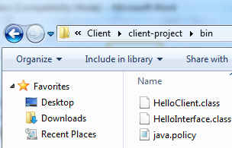 | 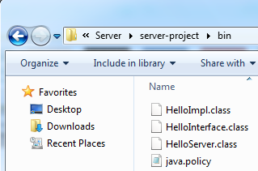

1. Open a DOS window for the server and a DOS window for the client.
2. Change the directory to the folder: bin in both DOS windows.
3. On the DOS prompt for the server enter:

java -Djava.security.policy=java.policy HelloServer

5. On the DOS prompt for the client enter:

java -Djava.security.policy=java.policy HelloClient

Outputs:
Output in the DOS window for the server:

RMI registry created at port 52365
Hello Server ready.

Output in the DOS window for the client:
Lookup completed
HelloClient: Hello, World!Donald Duck

Description:

The only instruction added with respect to the programs in example 1 of chapter 7 in both: HelloServer.java and HelloClient.java is:

System.setSecurityManager(new SecurityManager());

By adding this instruction when we run the java program the JVM is looking in folder: bin for a policy file. In this file we have one instruction (the rest are comments):

permission java.net.SocketPermission "*:1024-65535", "connect, accept, resolve";

This means the permission of any client that communicates with the server through a port number in the range: 1024-65535 is granted. The port number in both programs is: 16790.

